

C5 Programación_Explorador_Virtual _L2

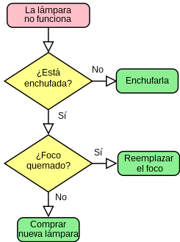*Oscar Ricardo Jurado Zambrano*

*PROFESSOR of ENGLISH: Carlos Moreno*

*Monitora: Dayana hurtado.*

***ACTIVIDAD***

***FORO 2:******Lección 2 Taller:***

*San Juan de Pasto, 30 mayo 2025*

***FORO 1: Lección Taller:***

***Activity 1:*** *Cuestionario preguntas de seleccion multiple respecto a la comprensión del siguiente texto.*

***Software Development***

*Software development is the process of developing a software product.*

*The process typically involves computer programming, testing, and debugging. The product may be a computer program or another software product. Software development often requires expertise in many different subjects, including computer programming, economics, engineering, mathematics, and psychology.*

*Software engineering is the discipline that integrates techniques and tools for software development with a process for managing the risks associated with software development. Software engineering has many subfields, including software design, testing, and implementation.*

*Software testing is an independent or integrated component of the software engineering process that verifies that a system meets its requirements before it can be released to customers.*

*Software developers are a very important part of the tech industry. They are responsible for designing, developing, and testing software. They are also responsible for making sure that the software is bug-free and works smoothly.*

*Software developers have to be skilled in computer programming languages like Java, C++, Python, etc. They also need to be knowledgeable about different operating systems like Windows, Linux, etc.*

*Software developers work in a variety of industries, including healthcare, finance, retail, and education. They can specialize in one or more programming languages such as Java or Python.*

***CUESTIONARIO.***

***Unit 2: Software Development***

***Lesson 1:*** *Based on the previous reading about Software Development, answer the following multiple-choice questions.*

*Choose the option that best answers each question based on the information in the text.*

*1. What does software development typically involve?*

*a) Only computer programming*

*b) Programming, testing, and debugging*

*c) Economics and psychology only*

*2. What is the role of software engineering in software*

*development?*

*a) To manage risks associated with development*

*b) To focus only on programming*

*c) To handle marketing strategies*

*3. What is the purpose of software testing in the development*

*process?*

*a) To market the software*

*b) To verify that a system meets requirements before release*

*c) To design the software interface*

*4. What are software developers responsible for?*

*a) Only testing the software*

*b) Designing, developing, and testing software*

*c) Direct sales of software*

*5. Which skills are essential for software developers?*

*a) Skills in multiple programming languages*

*b) Expertise in graphic design*

*c) Mastery of foreign languages*

*6. In which of these industries do software developers NOT*

*typically work?*

*a) Automotive manufacturing*

*b) Healthcare*

*c) Education*

*7.Software developers can specialize in:*

*a) One or more programming languages like Java*

*b) Hardware development*

*c) Legal aspects of software*

***PASADO VERBOS REGULARES*** *(Pronunciacion como D, como T o como ID)*

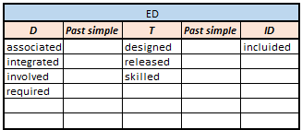

***Vocabulary y Parafraseo:***

*Encounter: An interaction, whether brief or meaningful, with someone or something.*

*Envisioned: To foresee or mentally project how something might look or develop.*

*Mere: Used to emphasize how small or insignificant something is*

*Ahead: Leading or making progress*

*Groundbreaking: Being the first of its kind, leading the way for future developments*

*Programming Language: It's a formal language that allows instructing a computer to perform specific tasks.*

*Step: part of a process*

*Develop: Build or investigate something related to science or technology.*

*Research: Activity related to science, or a person who does science*

*Design: First or second level in the process of building something*

*Debug: it's the process to identify errors and correct errors*

*Test: process to evaluate the knowledge, skill, etc*

*Smoothly: without any sudden change*

*Deploy: small scale activities designed to streamline processes*

*Engineering: Application of science and technology to solve problems*

*Subfields: part of a sistem*

**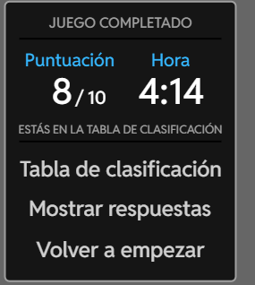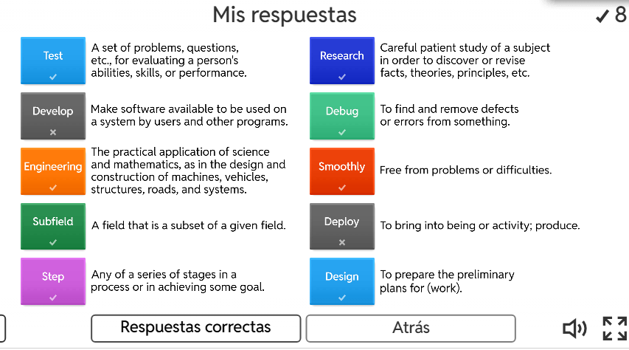*Activity***

***Activity 2:***

***Instructions:*** *Completar con palabras que usted considere pueden ir en el texto o con las que se acuerde.*

*Ada Lovelace is widely recognized as the world's first computer programmer. She was a British mathematician and writer who, in the 1840s, recognized the potential of Charles Babbage's Analytical Engine beyond pure calculation and developed the first algorithm designed to be carried out by a machine. Her work, including her extensive notes on the Analytical Engine, is considered foundational to computer science.*

***Early Life and Education:****Ada Lovelace was born in 1815 as the only legitimate child of Lord Byron and Annabella Milbanke. Her mother, a mathematician, heavily influenced her education, pushing her towards math and science rather than the arts, which were more common for women of her time.*

***Notes on the Analytical Engine:****Lovelace translated an Italian mathematician's article on the Analytical Engine and added extensive notes of her own. These notes included what many consider to be the first algorithm intended to be executed by a machine, a program for calculating Bernoulli numbers*

***Recognition of Computational Potential:***

*Lovelace’s notes highlighted the Analytical Engine’s potential for more than just number crunching, emphasizing its ability to follow a series of instructions to solve problems. She envisioned the engine as a tool for a wide range of tasks, including even composing music.*

***Legacy:***

*Lovelace’s work was largely forgotten until the mid-20th century, when computer scientists rediscovered her notes and recognized their significance. Today, she is celebrated as a pioneer of computer science and is recognized for her foresight in understanding the potential of computing machines. The programming language Ada, developed in the 1970s, is named after her in recognition of the groundbreaking work.*

***Activity 3: Que entendio del video en ingles***

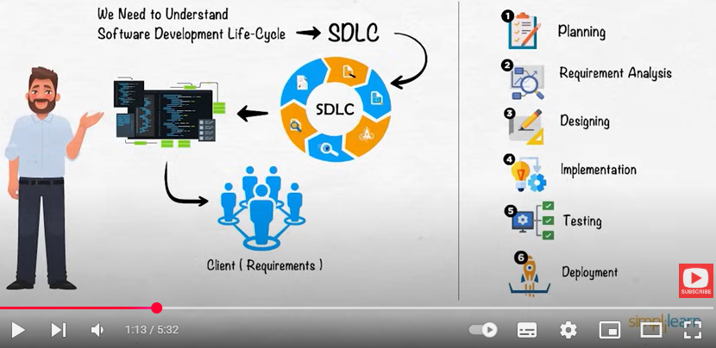

*Introduction To Software Development LifeCycle | What Is Software Development? | Simplilearn*

*El video expone sobre las 6 etapas que se requieren tener en cuenta para el desarrollo e implementación de un software “APP” para una aplicación especifica. Dentro de cada etapa hay unas subetapas y las explica detalladamente. Tambien expone sobre dos documentos que se deben diligenciar como producto de este proceso, que son las especificaciones requeridas del software y las especificaciones de diseño*

***Unit 2 N.5 Reading software development process***

*Read the process find English meaning and plan a software development process in groups.*

*Disenar un software aplicando esas etapas*

